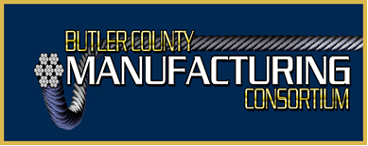

Friday, January 22, 2021
1:30 PM
Agenda

- Welcome and Introductions

- Minutes

- Treasurer’s Report

- Grant Update/Incumbent Worker Training

- BCMC Scholarship

- BCMC Government Advocacy Committee Update

- Co-Chair/Officers Needed

- Blog/Website Volunteers Needed

- 2021 Planning

- Manufacturer’s Updates

- Next Meeting – February 19, 2021 – 1:30 PM – Virtual
BCMC Goals
- Networking (Best practices; supply chain; procurement opportunities, etc.)
- Government Voice (Legislation impacts on manufacturing)
- Education/Training – Professional Development of the Workforce
- Secondary (K-12) Educational System (growing and promoting career interest in manufacturing – understanding skills and abilities for areas of interest)

